PRESS RELEASE

Join us for a family event [Or Other Event Name] that will be fun and engaging for all ages. Kolby and Mary Beth King share life truths in a fast-paced way often featuring ventriloquism, illusions, drama, fire-eating, humorous illustrations, balloon animals, high-energy songs, stunts with 6-foot balloons and more. You can learn more about their ministry at www.threethirtyministries.org. Coming to [Church Name] on [Date]. For more information, contact us at [Your Phone Number and/or Website].

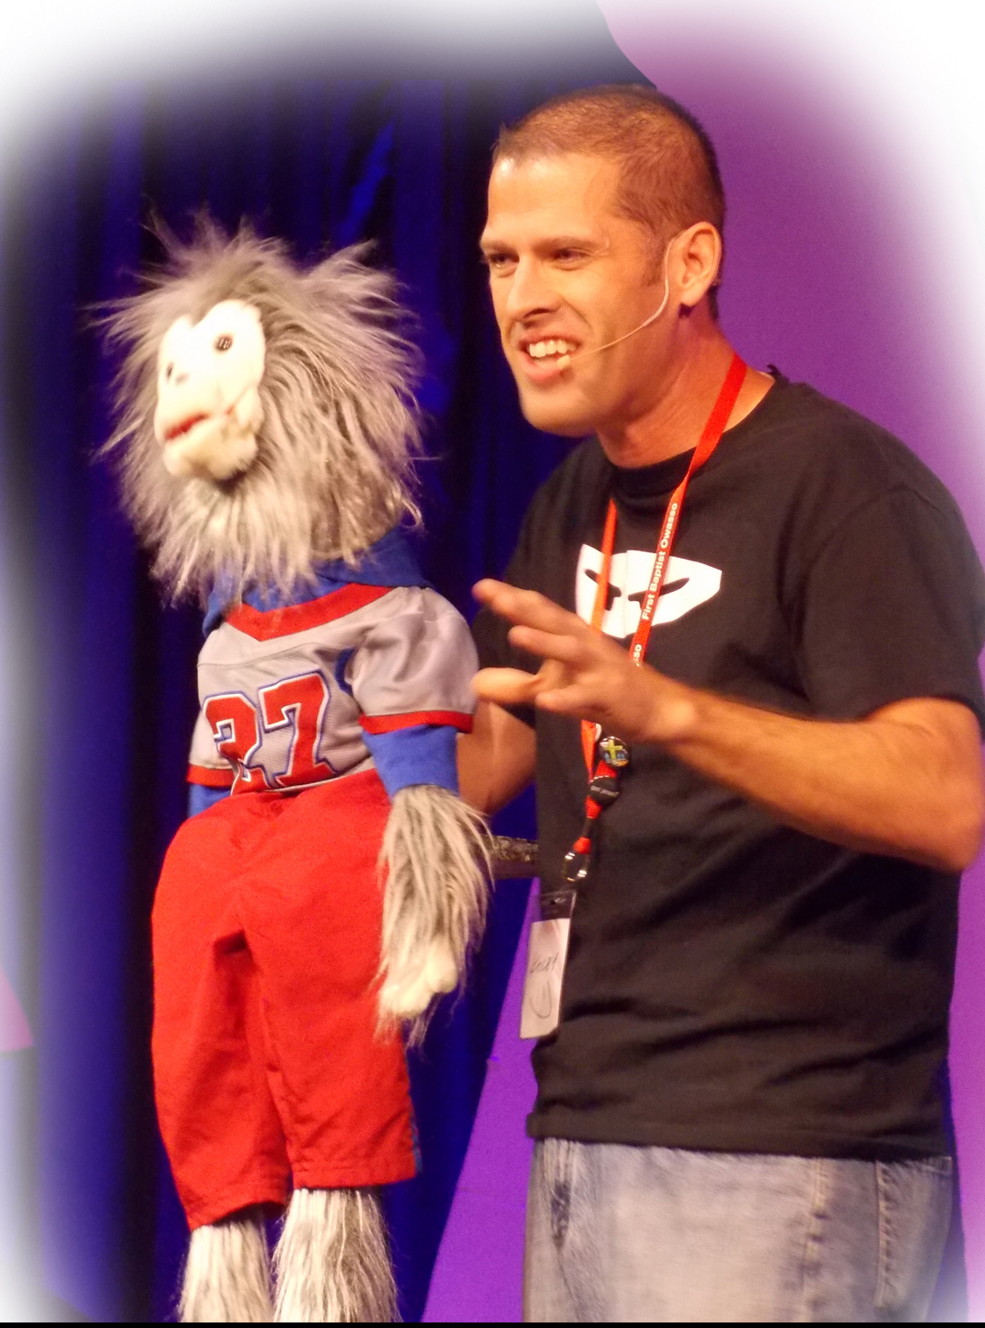

More photos and promotional information are available at:
www.threethirtyministries.org/promo

To set up interviews, please contact Kolby King at: kolbyking@threethirtyministries.org

